A

PROJECT REPORT OF

INFORMATICS PRACTICES

ON

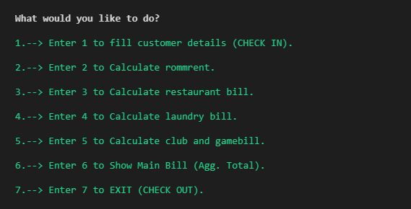 “**HOTEL MANAGEMENT SYSTEM**”

Submitted By: Ankit N Patne

XII (Science)

Year: 2020-21

Roll no. _____

CERTIFICATE

This is to certify that Master Ankit Patne of XII-A (Science) of Army Public School Devlali has successfully completed the project in Informatics Practices as a part of his curriculum academic year 2020-2021.

______ _______ _______

Internal Principal’s External

Examiner’s Signature Examiner’s

Signature Signature

**ACKNOWLEDGEMENT**

I would like to give my sincere gratitude to our principal Mrs. Medha Gode for giving me an opportunity to do this project.

I express my sincere thanks to our Informatics Practices teacher Mrs. Archana S Patil who guided me throughout the completion of project. This would have not been possible without the cooperation and direction provided by her.

Ankit N Patne

XII (Science)

**INDEX**

**DESCRIPTION OF THE PROJECT**

**TECHNICAL SPECIFICATIONS:**

**Hardware requirement (Minimum):**

• Processor-Intel Core I3

• CPU E2180@200 GHz

• Monitor-color CRT/TFT

• System type- 32/64 bit

• RAM- 4 GB

• Hard disk-1 TB DDR3/DDR4, 512 GB SSD

**Software requirement (Minimum):**

• Python IDLE 3.7

• MySQL Server 5.7

• MS-Word 2016

• Windows professional (Service pack-1)